**Association of state marijuana legalization policies for medical and recreational use and vaping associated lung disease**

Coady Wing, PhD, Indiana University O’Neill School of Public and Environmental Affairs

1315 E 10th St., Bloomington, IN 47405, [cwing@indiana.edu](mailto:cwing@indiana.edu), +1 (812) 855-0563

Ashley C. Bradford, MA, Indiana University O’Neill School of Public and Environmental Affairs

Aaron E. Carroll, MD, MS, Indiana University School of Medicine

Alex Hollingsworth, PhD, Indiana University O’Neill School of Public and Environmental Affairs

**Word Count: 594**

**Introduction**

In the past six months, over 1,600 cases of e-cigarette or vaping associated lung injury (EVALI) have been reported to the CDC. The specific cause of EVALI is unknown, but most patients report using e-cigarettes to consume tetrahydrocannabinol (THC), the primary psychoactive component of marijuana. The CDC and others have hypothesized that black-market THC products may cause EVALI1,2.

Some states have legalized marijuana and THC-containing products for recreational use. Many other states allow purchases for qualifying medical purposes. In the remaining states, all forms of consumption and distribution are illegal, and those who use THC likely obtain it from the black market. If black market THC products are responsible for EVALI, then case rates may be lower in recreational marijuana states. The goal of this cross-sectional study was to measure the extent to which states where marijuana is legal have lower rates of EVALI than states where it is illegal.

**Data**

We conducted analysis at the state level. We obtained data on the number of reported EVALI for each state from the CDC (2019)2, estimates of the prevalence of current e-cigarette use in each state from BRFSS (2017)3, and estimates of state populations from SEER (2017)4. We defined the EVALI case rate in a state as the mid-point of the CDC reported range of cases divided by the state population. We classified states as medical marijuana states if they had a medical marijuana law by January 2019, but no recreational dispensaries. We classified states as recreational marijuana states if they had a recreational law and at least one recreational dispensary by January 2019: Alaska, Washington, Colorado, Oregon, Nevada, California, and Maine.

Mention sample size.

**Methods**

Throughout, the unit of analysis was the state and all analyses are unweighted. We estimated a linear regression of the state EVALI case rate per 1 million people on indicator variables for recreational marijuana states and medical marijuana states, leaving prohibition states as the reference group. The coefficients on the marijuana law variables are estimates of the difference in mean unadjusted EVALI case rates in recreational vs prohibition states and medical vs prohibition states.

Differences in the popularity of e-cigarette use might confound the relationship between EVALI and state marijuana laws. To confound the state law effect, e-cigarette use would have to differ across states with recreational, medical, and prohibition laws. We investigate this possibility by fitting linear regressions of state level prevalence of e-cigarette use on indicator variables for recreational and medical marijuana laws. We also fit an augmented regression of EVALI case rates on both the state laws and e-cigarette prevalence. We estimated heteroskedasticity robust standard errors, used two-tailed t-tests to assess the null hypotheses of no effect, and rejected the null if the p-value was less than .05. All analysis was conducted using R 3.6.1.

Mention cross-sectional

Make sure that regression is mentioned here.

**Results**

The top panel of figure 1A shows the number of reported EVALI cases/million in each state. Recreational marijuana states are shown as diamonds in the figure and they have among to lowest number EVALI cases/million of all the states. We used regression of case rates on indicators for recreational and medical marijuana laws to test differences in average EVALI case rates. The results are in the bottom panel of Figure 1A. The average recreational marijuana state had 1.7 EVALI cases/million [CI]. In contrast, the EVALI case rate was 8.8 cases/million [CI] in medical marijuana states and 8.1 cases/million [CI] in prohibition states. A test of the difference in mean case rates implies that recreational marijuana states have 7.1 (p < .001) fewer cases/million than medical marijuana states, and 6.4 (p = .004) fewer cases/million than prohibition states. The difference in the EVALI case rate between medical and prohibition states is not statistically significant.

The top panel of figure 1B shows the prevalence of e-cigarette in each state. To test for systematic differences in e-cigarette use, we regressed e-cigarette prevalence on marijuana law indicators. The bottom panel of figure 1B that the average e-cigarette use rate is quantitatively similar across the three groups of states and none of the differences are statistically significant at conventional levels. Figure 3 shows a scatter plot of EVALI case rates against e-cigarette use rates. The graph suggests no association between EVALI cases rate and the prevalence of e-cigarette in each state, but it does show that EVALI rates are lower in recreational marijuana states. We also used multivariable regression to estimate the association between the EVALI case rate and marijuana laws after adjusting for the prevalence of e-cigarette use. The results confirm our earlier findings. Average EVALI case rates are 7.5 cases/million lower in recreational marijuana states (p < .001). There is no significant relationship between EVALI and medical marijuana (coef = 0.3, p = .92) or e-cigarette use (coef = -1.3, p = .20).

Add s.e. p-values and Cis for each thing mentioned.

Mention confounding. No missing data.

**Discussion**

The data suggests EVALI cases are concentrated in states where consumers do not have legal access to recreational marijuana dispensaries. This relationship does not appear to be explained by state level differences in e-cigarette use, and EVALI case rates are not strongly correlated with state level prevalence of e-cigarette use. or is protective against The reason for the relationship is not yet clear. It is possible that in recreational states people tend to purchase marijuana products at legal dispensaries, which are less likely to sell the contaminated products that cause EVALI. However, the statistical analysis in this note is limited in that these are simple cross-sectional comparisons of case rates, which do not attempt to adjust for the possibility of confounding by many other factors that might explain differences in EVALI case rates. To date, we know very little about the complicated interactions between safety regulations, bans, and prohibitions for goods like marijuana, tobacco, and vaping products. Future research should examine these issues in more detail.

Add the word bias.

Add the word not a random experiment.

Add generalizability.

Acknowledgements

Dr Wing and Dr Hollingsworth had full access to all the data in the study and take full responsibility for the integrity of the data and the accuracy of the data analysis.

Mention no funding.

Dr. Wing and Dr. Hollingsworth are responsible for ensuring that this report followed the STROBE guidelines for cross-sectional studies.

Figure 1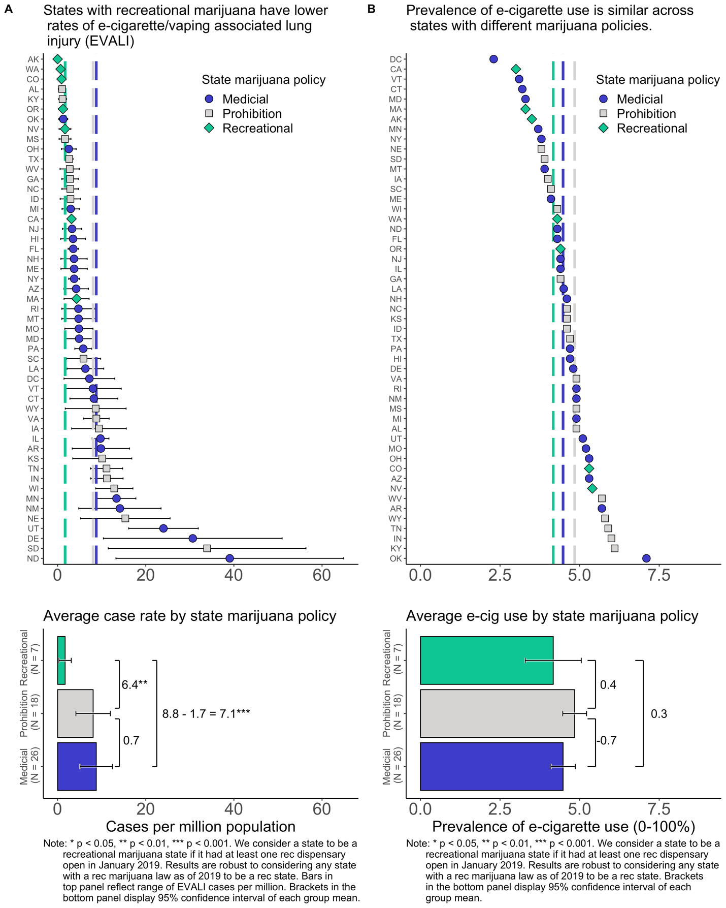

Figure 2

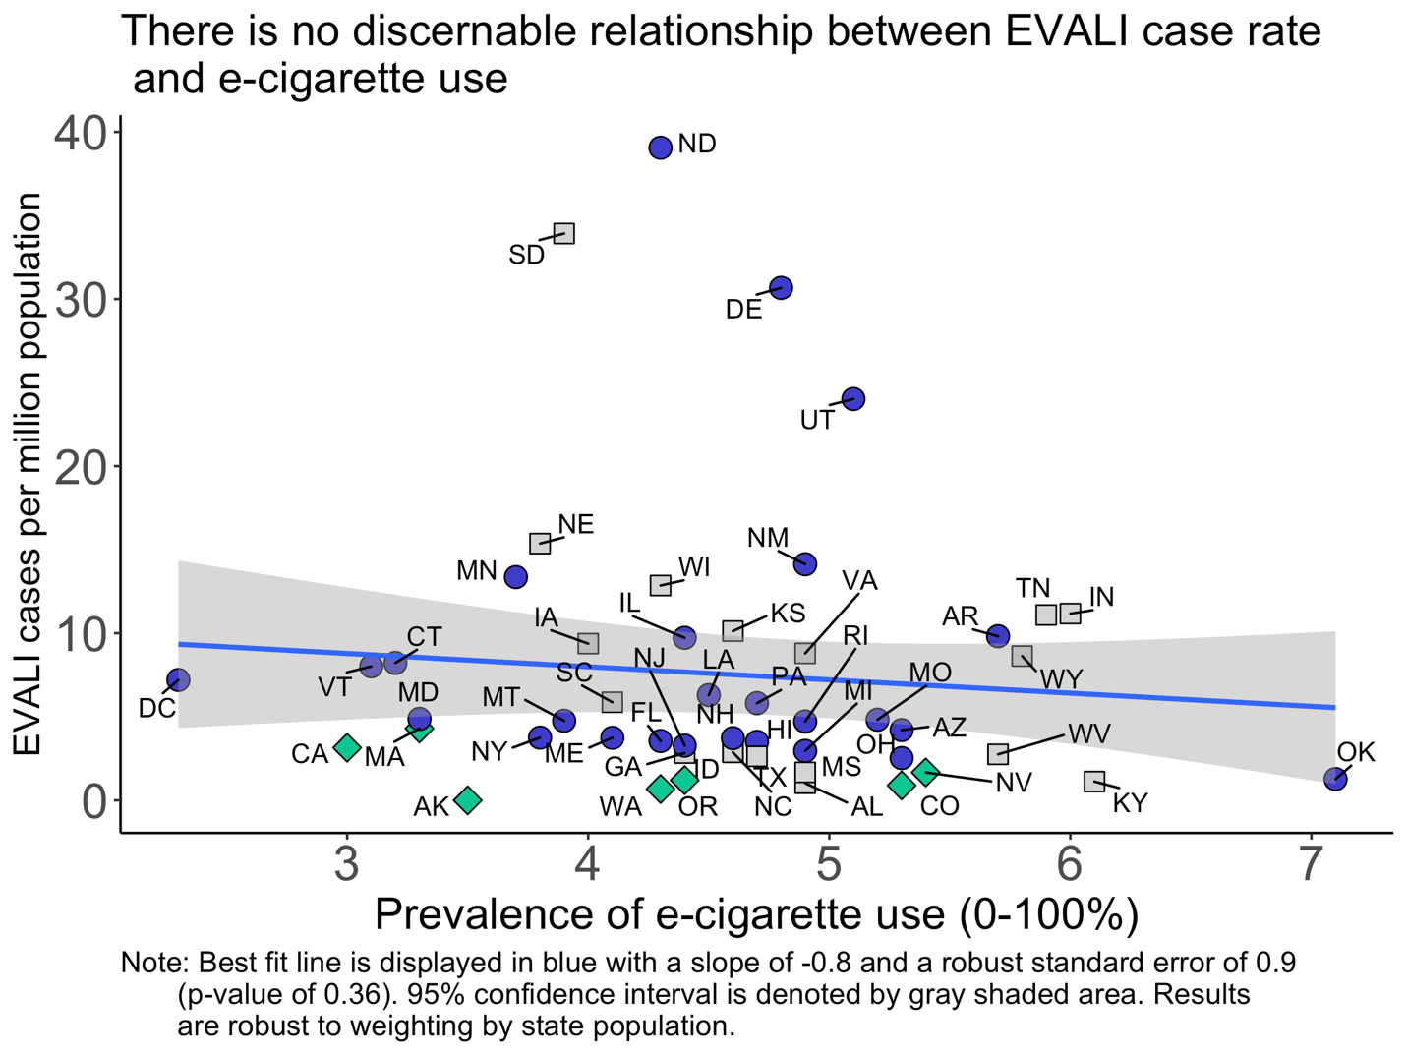

**References**

[1] Layden JE, Ghinai I, Pray I, et al. Pulmonary illness related to e-cigarette use in Illinois and Wisconsin — preliminary report. N Engl J Med. DOI: 10.1056/NEJMoa1911614.

[2] Perrine CG, Pickens CM, Boehmer TK, et al. Characteristics of a Multistate Outbreak of Lung Injury Associated with E-cigarette Use, or Vaping — United States, 2019. MMWR Morb Mortal Wkly Rep 2019;68:860–864. DOI: <http://dx.doi.org/10.15585/mmwr.mm6839e1>

[3] Centers for Disease Control and Prevention (CDC). Behavioral Risk Factor Surveillance System Survey Data. Atlanta, Georgia: U.S. Department of Health and Human Services, Centers for Disease Control and Prevention, 2017.

[4] Surveillance, Epidemiology, and End Results (SEER) Program Populations (1969-2017) (www.seer.cancer.gov/popdata), National Cancer Institute, DCCPS, Surveillance Research Program, released December 2018.

[5] Farzal, Z., Perry, M. F., Yarbrough, W. G., & Kimple, A. J. (2019). The Adolescent Vaping Epidemic in the United States—How It Happened and Where We Go From Here. JAMA Otolaryngology–Head & Neck Surgery, 145(10), 885. <https://doi.org/10.1001/jamaoto.2019.241>

[6] Karlamangla, S. (2019). Los Angeles could ban all e-cigarettes and vaping devices. *Los Angeles Times*. Retrieved from <https://www.latimes.com/california/story/2019-10-08/e-cigarettes-vaping-devices-proposed-ban-los-angeles>. Accessed 1 November 2019.